ACKNOWLEDGEMENT

Name of the Student (Size 14).

Table of Content
List of Abbreviation i
List of Tables ii
List of Figures iii
List of Graphs iv
Page no
Chapter 1. Introduction
- Introduction of respective area
- Motivation
- Problem statement and Objective
- Organization of the project
- Summary
Chapter 2. Related Work
    - Introduction to Existing System
    - Advantage of Existing System
    - Drawback/Limitation of Existing System
    - Comparison chart of Existing System
    - Summary
Chapter 3. Proposed Work
- Methodology (Algorithm/Method/Procedure etc.)
- Project Flow (Flow Chart etc.)
- Advantages.
Chapter 4. Implementation
- Details of Implementation
  - -----
  - ------
- Summary
Chapter 5. Result and Discussion
- Results
- Discussion
- Summary
Chapter 6. Conclusion and Future Scope
- Contribution of this work
- Scope of Future Work

Appendix

Bibliography

List of Related Publications

Chapter-1-

Chapter 1. Introduction
- Introduction of respective area
This assignment is another form of anonymity ,as used in secure multi party assignment is anonymous in that the identities received are unknown computation, allows multiple parties on a network to jointly to the other members of the group. Resistance to collusion among carry out a global computation that depends on data from each other members is verified party while the data held by each party remains unknown to private communication channels used. Is its capability of offloading the clouds e clients, thus minimizing the processing costs induced by the TRE algorithm. Unlike previous solutions, PACK does not require the status. This makes PACK server to continuously maintain clients very suitable for pervasive computation environments that combine client mobility and server migration to maintain cloud latest technique, which allows the simplicity this assignment of serial numbers allows more complex data to be shared and has applied to the other parties.
This assignment is anonymous in that the identities received are unknown to the other members of the group. Resistance to collusion among other members is verified in an information theoretic sense when private communication channels are used. This assignment of serial numbers allows more complex data to be shared and has applications to other problems in privacy preserving data mining, collision avoidance in communications and distributed database access.

- Motivation
I felt the urge to introduce the system which will consume less data. Most of the modern system are data sensitive cloud platform bill on the basis of data consumption.
Reduce the data consumption by using the less data which was initially used for the purpose of SYN-ACK purpose for almost every now and then.
- Problem statement and Objective
The issues in the current systems are in Asian continents where data speed is a reason to worry. The bottleneck occurs when client applications are working at slower speed and application actually demands much higher speed.
This issues can be resolved by making most of the data speed available. Reduce unnecessary data usage. Make the system most secure in every way possible by keeping both sender and receiver parties unaware about their destination location.

- Organization of the project
Sender:
The project needs participating entity much like master slave relationship. The master will send the data to the queues which will be maintained outside the client and server system. Sender will also stuff the chunk START and END message between the data payloads. Sender will also have chunk generator,Packet generator module.
Middle ware:
Middle ware does not inter fare or perform filtering on the data. Middle ware is the layer which makes separation between client and sender. It is responsible to receive data from the sender and send the data packets to the receiver.
Receiver:
Receiver receives the message from the queue from the middle ware asynchronously. Receiver also takes out payloads from the chunks form message from the payload and displays it on console or may save it to the secondary storage.
- Summary
The system will help you to send receive the message and also helps to stuff and extract message from the chunk.
Chapter 2. Related Work
    - Introduction to Existing System
For the sake of clarity, we ﬁrst describe the basic receiver-drive no preparation of the PACK protocol. Several enhancements and optimizations are introduced in The stream of data received at the PACK receiver is parsed to a sequence of chunks. The chunks are then compared to the receiver local storage, termed chunk store. If a matching chunk is found in the local chunk store, the receiver retrieves the sequence of subsequent chunks, referred to as a chain. Using the constructed chain, the receiver sends a prediction to the sender forth subsequent data. Part of each chunk’s prediction, termed a hint, is an easy-to-compute function with a small-enough false positive value, such as the value of the last byte in the predicted data or a byte-wide XOR checksum of all or selected bytes. The prediction sent by the receiver includes the range of the predicted data, the hint, and the signature of the chunk. The sender identiﬁes the predicted range in its buffered data and veriﬁes the hint for that range. If the result matches the received hint, it continues to perform the more computationally intensiveSHA1-signature operation. Upon a signature match, the sender sends a conﬁrmation message to the receiver, enabling it to copy the matched data from its local storage.

- Advantage of Existing System
The existing systems were bit prone to redundancy but they were more assured and safe.
Implementation was generic and widely accepted as it was first concept to introduced. Existing systems were bit prone to redundancy but they were more safe and reliable.

- Drawback/Limitation of Existing System
It is not ideal for cloud computing. The cloud providers charge to the end user on the basis of data quantum of data consumption.
Not suitable for slow speed system since the system can not afford the too many audit related packet which hampers the performance of the receiving and sending systems.

- Comparison chart of Existing System
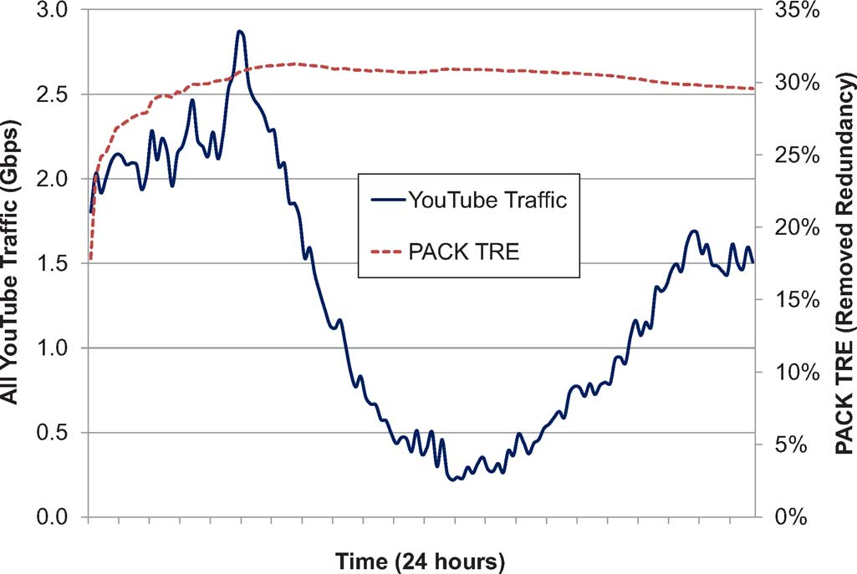
Fig: you tube traffic

- Summary
Existing system was just doing it’s job but it was not sensitive towards conservative use of data.

- Chapter 3. Proposed Work
- Methodology (Algorithm/Method/Procedure etc.)
Algorithm

- Project Flow (Flow Chart etc.)
Advantages.

References (In IEEE Format)
Paper Size : A- 4 size bond paper
Margins :
Top : 1”
Bottom : 1”
Left : 1.5”
Right : 1”

Main Heading (size 14)
Sub Heading (size 13)
Paragraph wording (size 12)
Line Spacing: 1.5 line
Font Style: - Times New Roman

Footer - is only corner of page “Godavari Foundation’s Godavari College of Engineering” (left Align) & Page no. Right Align
Header – Project Title

Numbering
The page numbering, from starting pages, should be printed in small Italic numbers, i.e, i, ii, iii, iv...... All page numbers from the chapter 1 should be printed using Arabic numerals i.e. 1, 2,3,4,5......

Binding- Black

Font Style: - Times New Roman

